Revision & Date : FTS30103

FTTH FTSTM

Fiber Optic Thermal Stripper

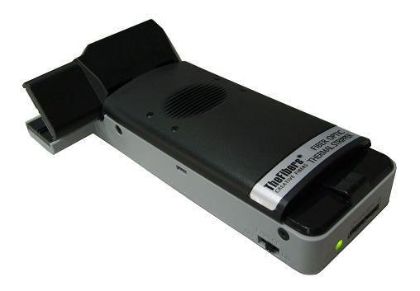
Special Features
• Very usefully device to strip coated fiber in FTTH
• Hand-held type Thermal Stripper
• Easy One Hand Operating
• Economic Price but High Strip-Quality
• No Fiber Scratch/Crack after stripping
• Safety Heating Controller
• High Performance Stripping Structure
• Available for Single Fiber and Ribbon Fiber
• Typical cell phone travel charger
• Anti-slip Grip Design
• Complied with RoHS
• CE/FCC approved

Specifications

Brand Name / Part Number FTS-900 FTS-250 FTS-RF
Applicable Fiber Type 900um Fiber 250um Fiber 12-Ribbon Fiber
Coating Range Stripped 900/250um 250um 400/250um
Heating Range Ceramic Heater 70 ~ 140℃ (max)
Fiber Strip Length (max) 35mm
Stripping Time 1 ~ 2 sec. (max) ¹
Input DC 4.2V 750mA TTA 24-Pin Charger²
Battery 3.7V 2200mA Rechargeable Lithium Ion Battery
Battery Running Time Approx. 4 hours
Power of Charger 110/220V@50/60Hz
Charging Time 4 hours
Dimension 150(l) x 25/45(w) ³ x 15(t) mm
Weight 150g (including Battery)
¹ After Warm Up (Warm Up Time: about 30 sec.)
² Typical cell phone 24-pin Charger
³ 25mm for Hand-held part, 45mm for Stripping part

Standard Package
P/N: FTS-900 / FTS-250 / FTS-RF
1 FTS (included Battery)
1 Typical 24-pin Charger
1 Necklace
1 Brush
1 Manual

TheFibers
C R E AT I V E F I B E R S
Manufacturer : TheFibers Inc.
A-1109 Keumkang Penterium IT Tower, 282 Hagui-ro, Anyang-City, Korea
Tel: +82-31-381-6108 Fax: +82-31-381-6109 sales@thefibers.com

